**CICS Commands**

Open Table files

**CEMT I FI(JT*)**

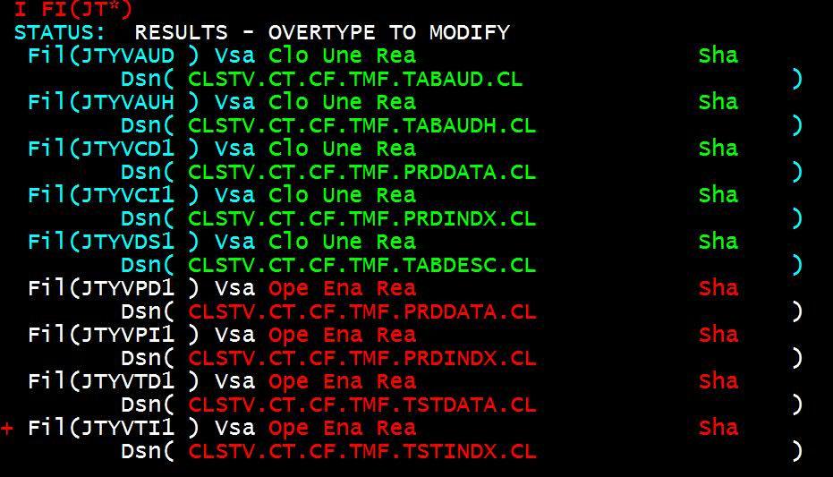

**Assign Transaction to a Program.**

**PCT entry**

Go to DS91 and 5th option use dummy transaction TC00

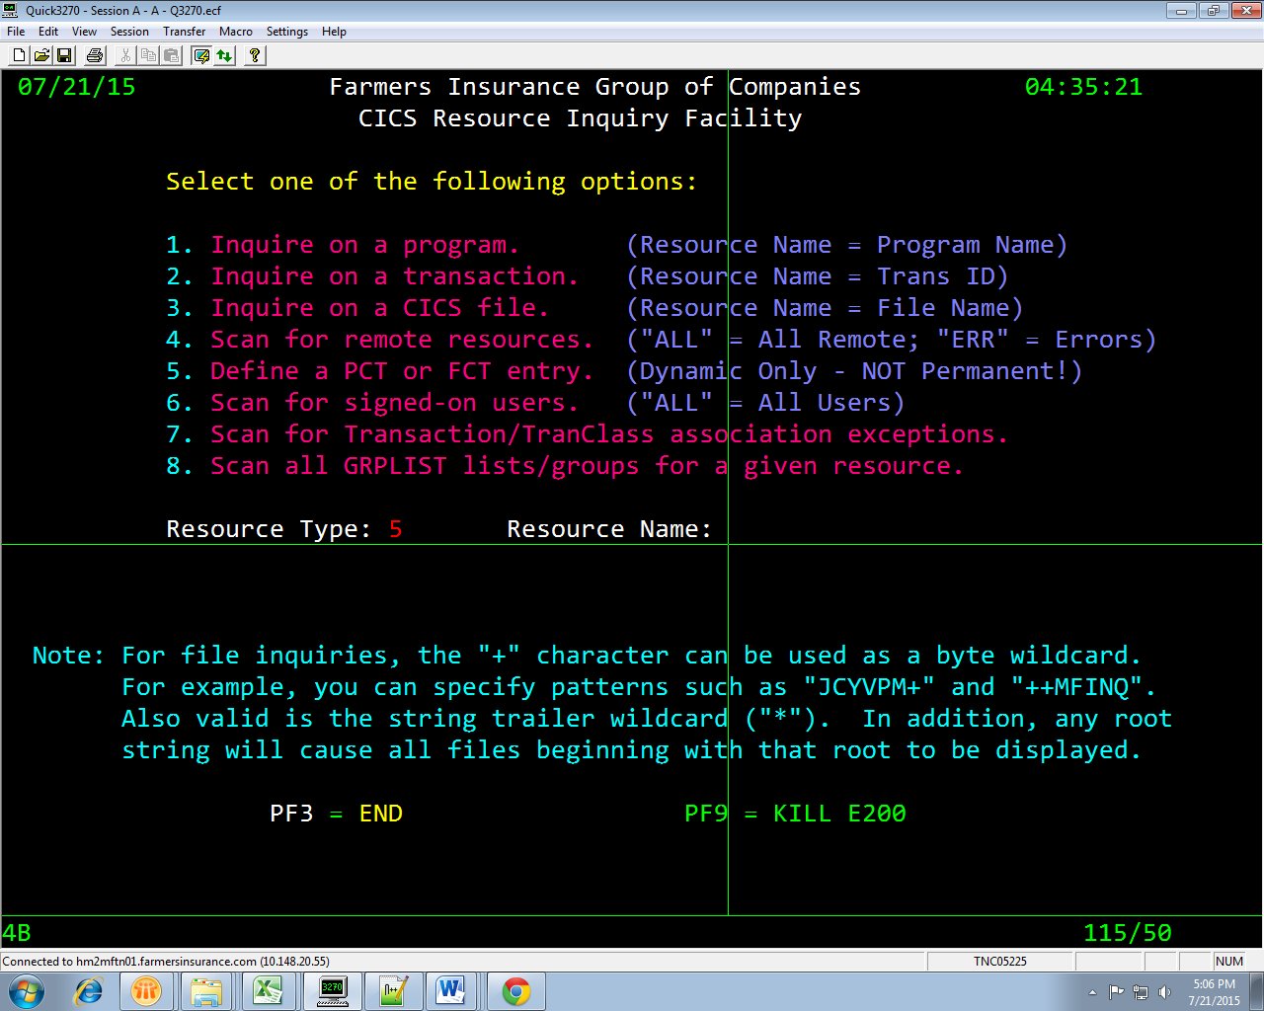

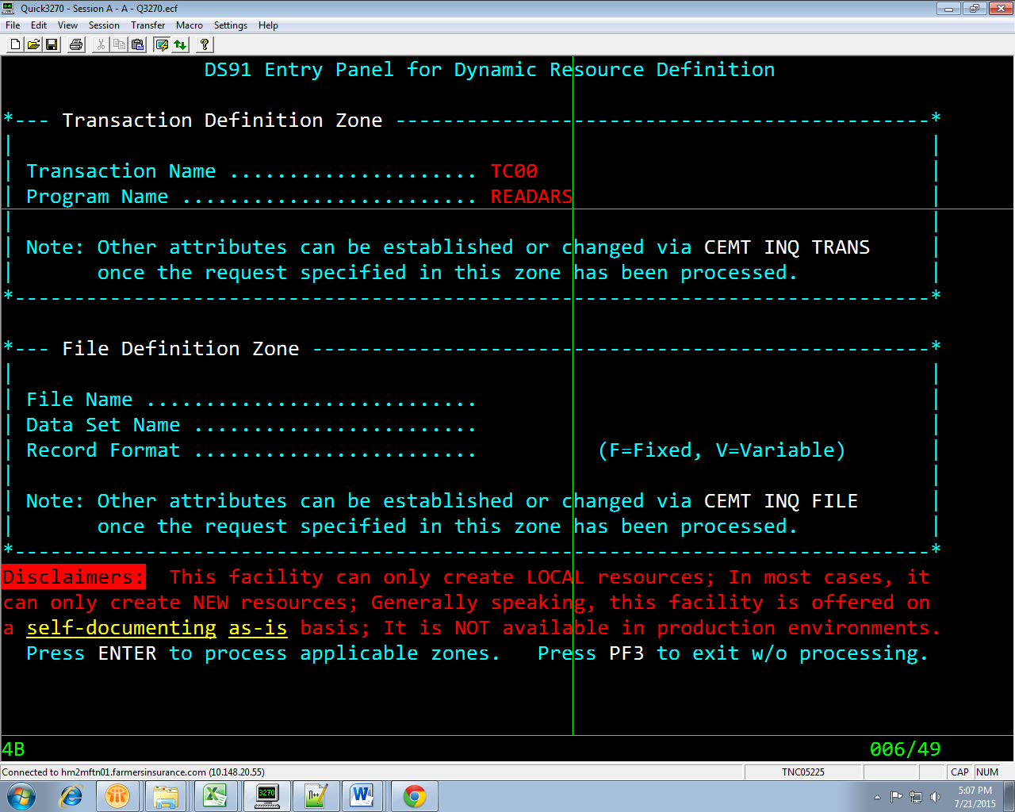

To View displays given in COBOL CICS pgms

Go to spool **pre CICS\***(say CICSTS41)

